List of Tables:
Table 1: Details of various MMM and their applications
Table 2: Cost and energy details of various MMM operations
List of Figures:
Fig. 1: (a) Schematic illustration of formation and preparation process of Tb-AIP flat sheet mixed matrix membrane and (b) Schematic illustration of formation and preparation process of Ultrathin ZIF-8 hollow fiber membranes (Fang, Montoro and Semsarilar, 2020)
Fig. 2: SEM images of cross-section of PES/Pb (II)-imprinted-MWNTs MMMs embedded with various wt% of Pb(II)-imprinted-MWNTs contents- A: 0%, B: 0.5%, C: 1.0%, D: 1.5% and E: 2% (Sun, Wu and Li, 2017)
Fig. 3: AFM images of cross-section of PES/Pb (II)-imprinted-MWNTs MMMs embedded with various wt% of Pb(II)-imprinted-MWNTs contents- A: 0%, B: 0.5%, C: 1.0%, D: 1.5% and E: 2% (Sun, Wu and Li, 2017)
Fig. 4: XPS spectra of (a) GO and PAMAM-GO having various generations; (b) C1s XPS spectra of GO; (c) C1s XPS spectra of GO-G4; (d) N1s XPS spectra of GO-G4 (Xio et al., 2016)
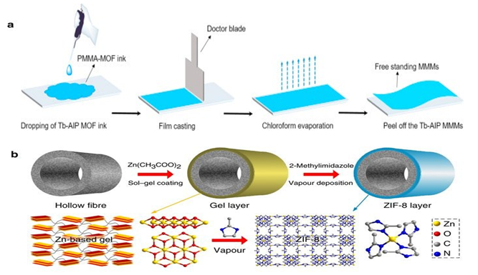

Figure 1 Schematic illustration of formation and preparation process of (a) Tb-AIP flat sheet mixed matrix membrane and (b) Ultrathin ZIF-8 hollow fiber membranes (Fang, Montoro and Semsarilar, 2020)

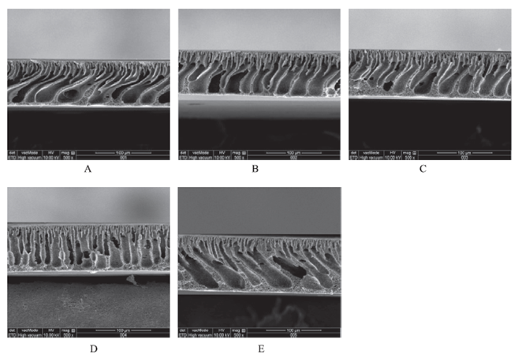
Figure 2 SEM images of cross-section of PES/Pb (II)-imprinted-MWNTs MMMs embedded with various wt% of Pb(II)-imprinted-MWNTs contents- A: 0%, B: 0.5%, C: 1.0%, D: 1.5% and E: 2% (Sun, Wu and Li, 2017)
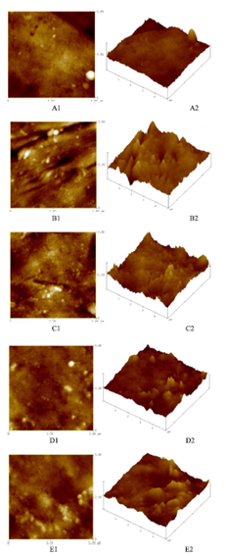
Figure 3 AFM images of cross-section of PES/Pb (II)-imprinted-MWNTs MMMs embedded with various wt% of Pb(II)-imprinted-MWNTs contents- A: 0%, B: 0.5%, C: 1.0%, D: 1.5% and E: 2% (Sun, Wu and Li, 2017)

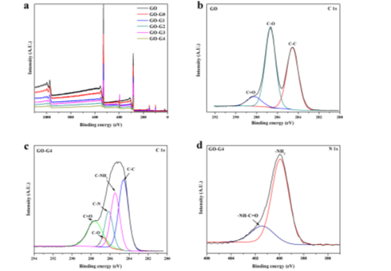
Figure 4 XPS spectra of (a) GO and PAMAM-GO having various generations; (b) C1s XPS spectra of GO; (c) C1s XPS spectra of GO-G4; (d) N1s XPS spectra of GO-G4 (Xio et al., 2016)

Table 1: Details of various MMM and their applications
S. No. | Polymer | Solvent | Inorganic | Type | Application | Reference
1. | PES and PVP | DMAc | Metformin/GO/Fe₃O₄ hybrid | Flat Sheet | Dye and Heavy Metal Removal | Abdi et al. (2018)
2. | PES and PVP | Deionized water | α-ZrP particles | Flat Sheet | Heavy Metals from wastewater | Abdulkarim E et al. (2019)
3. | PVP and PSf | NMP | Hydrous ferric oxide nanoparticles | Flat Sheet | Lead Removal | Abdullah et al. (2016)
4. | PES and PVP | DMAc | Graphene oxide nanoplates | Flat Sheet | Chromium Removal | Bagheripour et al. (2018)
5. | Polyphenylsulfone (PPSU) and PVP | NMP | CNTs | Flat Sheet | Lead, Mercury and Cadmium Removal | Chandrashekhar Nayak et al. (2019)
6. | CAP | DMF | Activated Alumina | Flat Sheet | Fluoride Removal | Chatterjee and De. (2014)
7. | Cellulose Acetate Phthalate (CAP) | DMF | Activated alumina powder | Flat Sheet | Fluoride Removal | Chatterjee and De. (2014)
8. | PAN and PVP | DMF | Laterite Nanoparticles | Flat Sheet | Arsenic Removal | Chatterjee and De. (2015)
9. | PES and PEG | DMF | Carbonized bone meal | Hollow Fiber | Fluoride Removal | Chatterjee, Mukherjee and De. (2020)
10. | PVDF | Deionized water | PAMAM Dendrimer-like Particles | Hollow Fiber | Copper Removal | Chemistry. (2010)
11. | Cellulose acetate (CA) | NMP | Anatase titania (ANT) nanoparticles | Flat Sheet | Copper, Cadmium and Manganese Removal | Delavar et al. (2020)
12. | Cellulose Acetate | NMP | HMO nanoparticles | Flat Sheet | Cadmium and Copper Removal | Delavar, Bakeri and Hosseini. (2017)
13. | PSf and PVP | DMAc | PANI-GO nanoparticles | Flat Sheet | Lead Removal | Ghaemi, Zereshki and Heidari. (2017)
14. | PVP and PSf | NMP | Uio-66 particles | Flat Sheet | Arsenic Removal | He et al. (2017)
15. | PSf | NMP | Zr-based nanoparticles | Hollow Fiber | Fluoride Removal | He, Siah and Paul Chen. (2014)
16. | PSf | Deionized Water | α-ZrP nanoparticles | Hollow Fiber | Heavy metals from wastewater | Ibrahim et al. (2019)
17. | Cellulose | Deionized water | α-ZrP nanoparticles | Flat Sheet | Nickel, Lead, Zinc and Copper Removal | Ibrahim et al. (2019)
18. | PSF | NMP | Titanium precursor-titanium tetrachloride | Flat Sheet | Chromium Removal | Jacob, Joseph and Varghese. (2020)
19. | PVP and PES | NMP | HMO nanoparticles | Flat Sheet | Lead Removal | Jamshidi Gohari et al. (2013)
20. | PEI and PVP | NMP | C-GO nanomaterial | Flat Sheet | Cadmium and Nickel Removal | Kaleekkal et al. (2017)
21. | Chitosan | Double Distilled Water | Poly(vinyl alcohol) powder | Flat Sheet | Lead and Cadmium removal | Karim et al. (2019)
22. | PAN | DMF | AlFu MOF | Hollow Fiber | Fluoride Removal | Karmakar, Bhattacharjee and De. (2018)
23. | PVDF and PVP | DMAc | ZIF-8 particles | Flat Sheet | Nickel Removal | Li et al. (2018)
24. | PSf | DMF | NFO Nanoparticles | Hollow Fiber | Heavy Metals from aqueous solution | Mondal, Dutta and De. (2017)
25. | PSf | NMP | Fe₃O₄–talc nanocomposites | Flat Sheet | Lead and Nickel Removal | Moradihamedani et al. (2016)
26. | PSf | DMF | GO nanoparticles | Flat Sheet | Lead, Copper, Cadmium and Chromium Removal | Mukherjee, Bhunia and De. (2016)
27. | Chitosan | DMF | Purolite particles | Flat Sheet | Mercury Removal | Saiful, Isni and Suhud. (2018)
28. | PVP and PES | NMP | GMF nanomaterial | Flat Sheet | Arsenic Removal | Shahrin et al. (2019)
29. | PPSUaz | NMP | C-GO nanomaterial | Flat Sheet | Heavy Metals from wastewater system | Shukla et al. (2018)
30. | PES and PVP | DMAc | Pb-imprinted MWNTs | Flat Sheet | Zinc, Cobalt and Calcium Removal | Sun, Wu and Li. (2017)
31. | PSf and PVP | NMP | Zeolite ZSM-5 | Flat Sheet | Lead and Cadmium Removal | Syed Ibrahim et al. (2017)

Table 2: Cost and energy details of various MMM operations
Sl. No. | Membrane | Solute | Cost per square meter of membrane material (USD) | Specific flux (L/m².h. kPa) | Energy consumption  (kWh per m² membrane area per m³ of processed water) | Energy Cost  (USD/m³ of fresh drinking water) | Reference
1. | Polyethersulfone nanofiltration membrane modified by magnetic graphene oxide/metformin hybrid | Copper | 328 | 1 × 10⁻¹ | 10 | 1 | Abdi et al. (2018)
2. | Polyethersulfone (PES) Alpha-Zirconium Phosphate (α-ZrP) ion exchange mixed matrix membranes | Copper, Zinc and Nickel | 77 | 30 | 4 × 10⁻² | 4 × 10⁻³ | Abdulkarim E et al. (2019)
3. | Polysulfone/hydrous ferric oxide ultrafiltration mixed matrix membrane | Lead | 125 | 1 | 9 × 10⁻¹ | 1 × 10⁻¹ | Abdullah et al. (2016)
4. | PES nanofiltration membrane with incorporation of composite  GOCs nanoplates | Chromium | 280 | 6 × 10⁻² | 21 | 2 | Bagheripour et al. (2018)
5. | Polyphenylsulfone/multiwalled carbon nanotubes mixed ultrafiltration membranes | Lead, Mercury, Cadmium | 176 | 1 | 1 | 1 × 10⁻¹ | Chandrashekhar Nayak et al. (2019)
6. | Activated alumina doped cellulose acetate phthalate (CAP) mixed matrix membrane | Fluoride | 84 | 1 × 10⁻¹ | 11 | 1 | Chatterjee and De. (2014)
7. | Polyacrylonitrile (PAN)–laterite mixed matrix ultrafiltration membrane | Arsenic | 538 | 1 | 10 × 10⁻¹ | 1 × 10⁻¹ | Chatterjee and De. (2015)
8. | Carbonized bone meal impregnated polysulfone mixed matrix hollow-fiber membranes | Flouride | 264 | 10 × 10⁻² | 2 | 2 × 10⁻¹ | Chatterjee, Mukherjee and De. (2020)
9. | Mixed matrix PVDF membranes with in-situ synthesized PAMAM 1 dendrimer-like particles | Copper | 3954 | 1 × 10⁻² | 179 | 20 | Chemistry. (2010)
10. | Polyvinyl chloride mixed matrix membranes containing high aspect ratio anatase titania nanoparticle | Cadmium | 83 | 1 | 1 | 1 × 10⁻¹ | Delavar et al. (2020)
10. |  | Copper | 83 | 10 × 10⁻¹ | 1 | 2 × 10⁻¹ | Delavar et al. (2020)
11. | Mixed matrix membranes containing hydrous manganese oxide and alumina nanoparticles | Cadmium and Copper | 123 | 6 | 2 × 10⁻¹ | 2 × 10⁻² | Delavar, Bakeri and Hosseini. (2017)
12. | PES–based nanocomposite membrane incorporated with polyaniline modified GO nanoparticles | Lead | 292 | 2 × 10⁻² | 75 | 9 × 10⁻¹ | Ghaemi, Zereshki and Heidari. (2017)
13. | Zr-based nanoparticle-embedded PSF blend hollow fiber membrane | Fluoride | 235 | 3 | 4 × 10⁻¹ | 5 × 10⁻² | He, Siah and Paul Chen. (2014)
14. | Super hydrophilic cellulose-alpha zirconium phosphate ion exchange membrane | Copper, Zinc, Nickel and Lead | 15 | 2 | 6 × 10⁻¹ | 7 × 10⁻² | Ibrahim et al. (2019)
15. | Novel PES/HMO ultrafiltration mixed matrix membrane | Lead | 95 | 6 × 10⁻¹ | 2 | 2 × 10⁻¹ | Jamshidi Gohari et al. (2013)
16. | PSf/TiO₂ mixed matrix membrane | Chromium | 138 | 2 × 10⁻¹ | 8 | 9 × 10⁻¹ | Jyothi et al. (2014)
17. | Carboxylated graphene oxide incorporated polyetherimide mixed matrix ultrafiltration membranes | Nickel and Cadmium | 53 | 4 × 10⁻¹ | 3 | 4 × 10⁻¹ | Kaleekkal et al. (2017)
18. | Composite nanofibers membranes made of poly(vinyl alcohol)/chitosan | Lead and  Cadmium | 1048 | ̶ | ̶ | ̶ | Karim et al. (2019)
19. | Aluminium fumarate metal organic framework incorporated polyacrylonitrile hollow fiber membranes | Fluoride | 248 | 4 | 2 × 10⁻¹ | 2 × 10⁻² | Karmakar, Bhattacharjee and De. (2018)
20. | Novel PAA/ZIF-8/PVDF hybrid ultrafiltration membrane | Nickel | 350 | 3 | 4 × 10⁻¹ | 4 × 10⁻² | Li et al. (2018)
21. | Cross flow ultrafiltration by mixed matrix membrane | Flouride | 80 | 5 × 10⁻² | 24 | 3 | Mondal, Chatterjee and De. (2015)
22. | Ultrafiltration grade nickel iron oxide doped hollow fiber mixed matrix membrane | Copper and Lead | 375 | 4 × 10⁻¹ | 1 | 1 × 10⁻¹ | Mondal, Dutta and De. (2017)
23. | Polysulfone/Fe₃O₄–talc nanocomposite mixed matrix membrane | Lead | 144 | 1 × 10⁻¹ | 8 | 10 × 10⁻¹ | Moradihamedani et al. (2016)
23. | Polysulfone/Fe₃O₄–talc nanocomposite mixed matrix membrane | Nickel | 144 | 8 × 10⁻² | 15 | 2 | Moradihamedani et al. (2016)
24. | Mixed matrix membrane containing Graphene oxide (GO) nanoparticles | Chromium, Cadmium, Copper and Lead | 405 | 1 × 10⁻¹ | 3 | 3 × 10⁻¹ | Mukherjee, Bhunia and De. (2016)
25. | Mixed matrix membrane doped with purolite | Mercury | 43 | 3 | 4 × 10⁻¹ | 5 × 10⁻² | Saiful, Isni and Suhud. (2018)
26. | Mixed matrix membrane incorporating graphene oxide-manganese ferrite (GMF) hybrid nanomaterial | Arsenic | 110 | 2 | 6 × 10⁻¹ | 7 × 10⁻² | Shahrin et al. (2019)
27. | Carboxylated graphene oxide-incorporated polyphenylsulfone nanofiltration membrane | Chromium, Arsenic, Lead, Zinc, Cadmium | 73 | 9 × 10⁻² | 15 | 2 | Shukla et al. (2018)
28. | Polyether sulfone/Pb(II)-imprinted multi-walled carbon nanotubes mixed matrix membrane | Zinc, Cobalt and Calcium | 1227 | 3 | 5 × 10⁻¹ | 5 × 10⁻² | Sun, Wu and Li. (2017)
29. | Polysulfone-Zeolite ZSM-5 mixed matrix membrane | Lead and Cadmium | 140 | 8 × 10⁻¹ | 2 | 2 × 10⁻¹ | Syed Ibrahim et al. (2017)
30. | Metal organic framework mixed-matrix membrane | Arsenic | 132 | 2 × 10⁻¹ | 8 | 9 × 10⁻¹ | Tajuddin et al. (2020)

